Dr. Cheryl L Brown, Director  Jacksonville City Council  904.630.1452  CLBrown@coj.net | 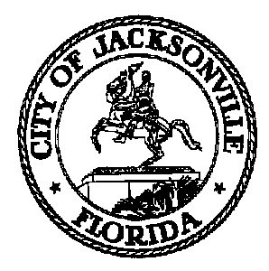 | 117 West Duval Street, Suite 425  Jacksonville, Florida 32202
SAFETY AND CRIME REDUCTION COMMISSION

Meeting Notice

December 17, 2019
5:00 p.m.

TO: Safety and Crime Reduction Subcommittee on Data and Research
Timothy Sloan | Linda Joseph
Camille Burban | Shelley Grant
Frank Denton

FROM: Ronnie King, Chair

SUBJECT: 20200114 Meeting Notice Safety and Crime Reduction Subcommittee on Data and Research

Notice is hereby given that the Safety and Crime Reduction Subcommittee on Data and Research will meet Tuesday, January 14, 2020 at 2:30 P.M. The meeting will be held in Committee Room B located at 117 W. Duval St., 1st Floor, City Hall - St. James Building. For additional information, please contact Carol Owens at cowens@coj.net or (904) 255-5168.

When attending Commission Meetings, Members are to park in the parking garage located on the corner of Main and Duval Street (Library Garage) to receive free parking. Please see Staff for parking validation.

Pursuant to the American with Disabilities Act, accommodations for persons with disabilities are available upon request.
Please allow 1-2 business days notification to process; last minute requests will be accepted, but may not be possible to fulfill.
Please contact Disabled Services Division at: V 904-255-5466 , TTY-904-255-5476, or email your request to KaraT@coj.net.

CLB/clo

cc: Cheryl Brown, Council Director
Carol Owens
Jeff Clements, Chief of Research
File
cityc@coj.net

